Software Description Document

**Project Name:** redTAG System  
**Version:** 2.0  
**Author:** Nolan Manteufel  
**Date:** 09 SEP 2024  
**Organization:** miniPCB

1. Introduction

## 1.1 Purpose

This Software Description Document (SDD) outlines the design, architecture, and functionality of the redTAG application, a tool designed to manage red tag messages and process messages related to printed circuit board (PCB) production. The application allows users to scan barcodes, apply labels, add custom messages, and manage PCB-related data. It also includes features for version control integration with GitHub.

## 1.2 Scope

The redTAG application is intended for use in electronics manufacturing environments where tracking and managing PCB-related issues, process messages, and red tag messages are crucial for quality control and process documentation.

## 1.3 Definitions, Acronyms, and Abbreviations

* PCB: Printed Circuit Board
* GUI: Graphical User Interface
* GitHub: A web-based platform for version control using Git
* JSON: JavaScript Object Notation, a lightweight data-interchange format
* TK: Tkinter, a Python GUI toolkit

## 1.4 References

* Tkinter Documentation: https://docs.python.org/3/library/tkinter.html
* GitHub Documentation: https://docs.github.com/en
* JSON Documentation: https://www.json.org/json-en.html

2. System Overview

The redTAG application provides a user-friendly GUI for managing process messages and red tag messages related to PCB production. The application includes features for barcode scanning, message management, version control, and session management. It is built using Python with the Tkinter library for the GUI and JSON for data storage.

3. System Architecture

## 3.1 Main Components

GUI Layer: The user interface, built with Tkinter, includes multiple tabs for different functionalities.

Data Management Layer: Handles the storage and retrieval of messages, labels, and test results in JSON format.

GitHub Integration Layer: Manages the synchronization of files with a GitHub repository.

## 3.2 System Components

Controls Tab

Sub-tabs: Process Messages, Red Tag Messages

Features: Scan Barcode, Delete File, Update from GitHub, Add New Process/Red Tag Messages, Apply Labels/Messages, Remove Labels/Messages

Board Information Tab

Displays board details such as Name, Variant, Revision, and Serial Number.

Sub-tabs: Process History, Messages, Testing

Trends Tab

Placeholder for future trends analysis functionality.

About Tab

Displays information about the application, including the author, version, and company details.

4. Detailed Design

## 4.1 User Interface Design

The application features a multi-tab interface where each tab is dedicated to a specific functionality. The main tabs are Controls, Board Information, Trends, and About. Each tab contains relevant widgets such as buttons, entry fields, and labels.

Controls Tab:

Process Messages: Allows users to add, apply, and remove process messages.

Red Tag Messages: Similar functionality for red tag messages.

Buttons: "Scan a Barcode", "Delete a File", "Update", "Apply Label/Message", "Remove Label/Message".

Board Information Tab:

Sub-tabs: Process History, Messages, Testing.

Labels: Display board information at the top of the tab.

About Tab:

Displays author information, version number ("Version 2.0"), and company details.

## 4.2 Data Storage Design

Data is stored in JSON format. The application uses two primary JSON files:

redLabels.json: Stores a list of process messages.

redTagMessages.json: Stores a list of red tag messages.

## 4.3 GitHub Integration

The application integrates with GitHub for version control. It includes functionality to:

Push updates to the GitHub repository after adding or modifying files.

Pull updates from GitHub to ensure the local data is up to date.

## 4.4 Barcode Parsing

The parse_pcb_barcode function extracts relevant information (Board Name, Revision, Variant, Serial Number) from scanned barcodes using regular expressions.

5. Functionality

## 5.1 Barcode Scanning

Allows users to scan PCB barcodes and populate board information.

Enables the Board Information and Trends tabs after a successful scan.

## 5.2 Process and Red Tag Message Management

Add New Message: Users can add custom messages related to PCB processes or red tags.

Apply Message: Selected messages can be applied to multiple boards sequentially.

Remove Message: Messages can be deleted from the JSON files.

## 5.3 File Management

Delete File: Allows users to delete files associated with specific PCBs, with GitHub sync.

Update from GitHub: Syncs local files with the latest versions from GitHub.

6. Error Handling

The application includes error handling mechanisms to manage file access, GitHub operations, and user input validation. Errors are displayed to the user using message boxes.

7. Security Considerations

The application handles user data, such as PCB information and GitHub credentials, securely. However, it does not implement advanced security features such as encryption or user authentication.

8. Versioning

Version 2.0: This version includes the basic functionality for managing PCB-related messages and integrates with GitHub for version control. It features a multi-tab GUI, barcode scanning, and JSON-based data storage.

9. Future Enhancements

Trends Analysis: Implement functionality to analyze trends in PCB production issues.

Report Generation: Add the ability to generate reports based on process and red tag messages.

Security Improvements: Introduce user authentication and data encryption.

10. Conclusion

The redTAG application is a comprehensive tool for managing PCB production messages, ensuring quality control through effective documentation and integration with version control systems. This SDD outlines the application's design and functionality, serving as a guide for further development and maintenance.

# Appendix: Screen Layouts and Descriptions

This appendix provides visual representations and descriptions of each screen in the redTAG system as of version 2.0. The screens are presented in the order a typical user might encounter them.

## A.1 Welcome Screen

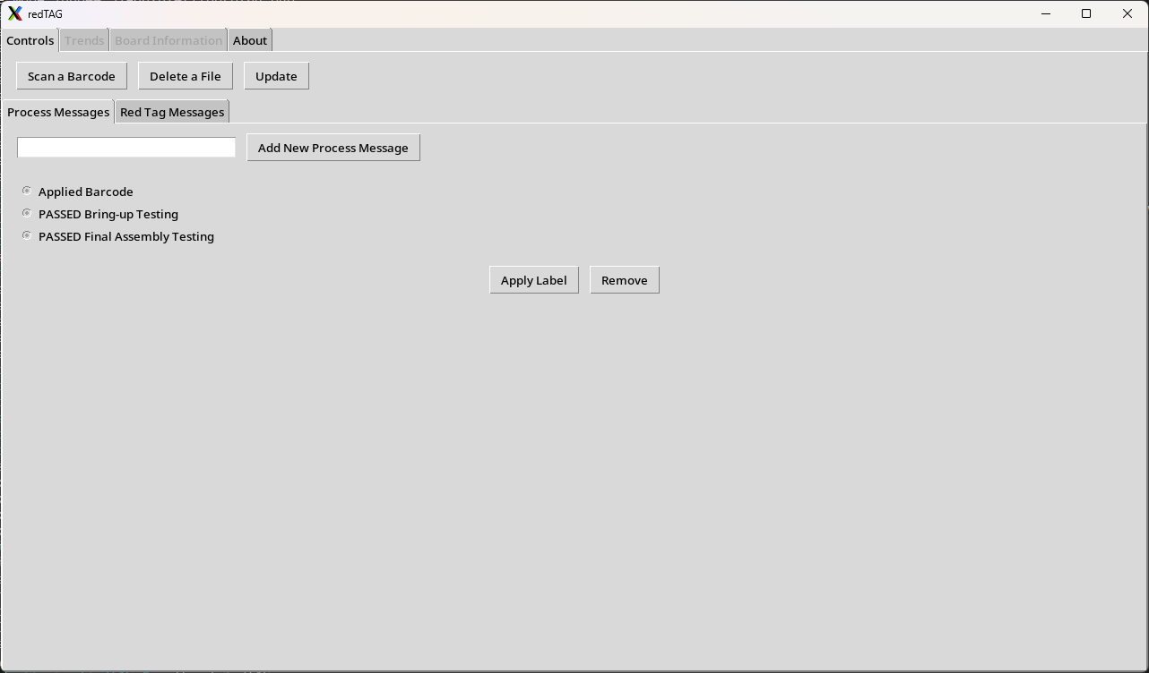

## A.2 Red Tag Messages Screen

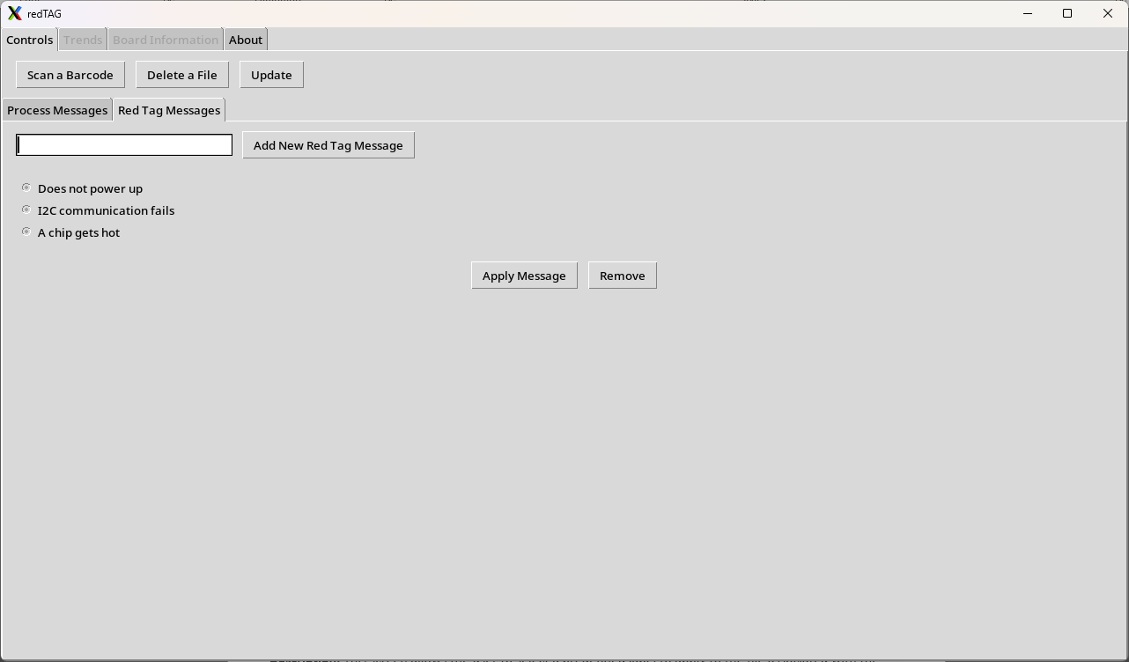

## A.3 Scan Barcode Screen

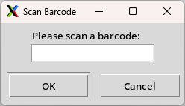

## A.4 Board Information, Messages Screen

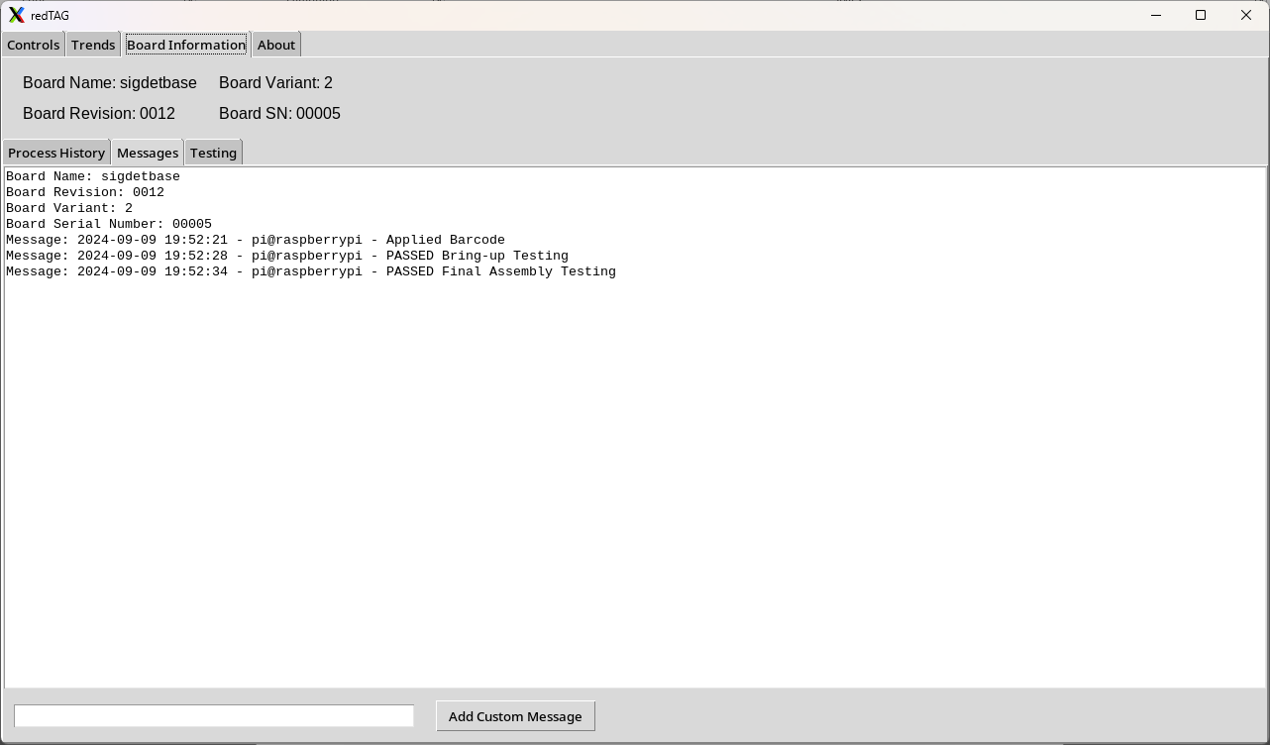

## A.7 Message Entry Screen

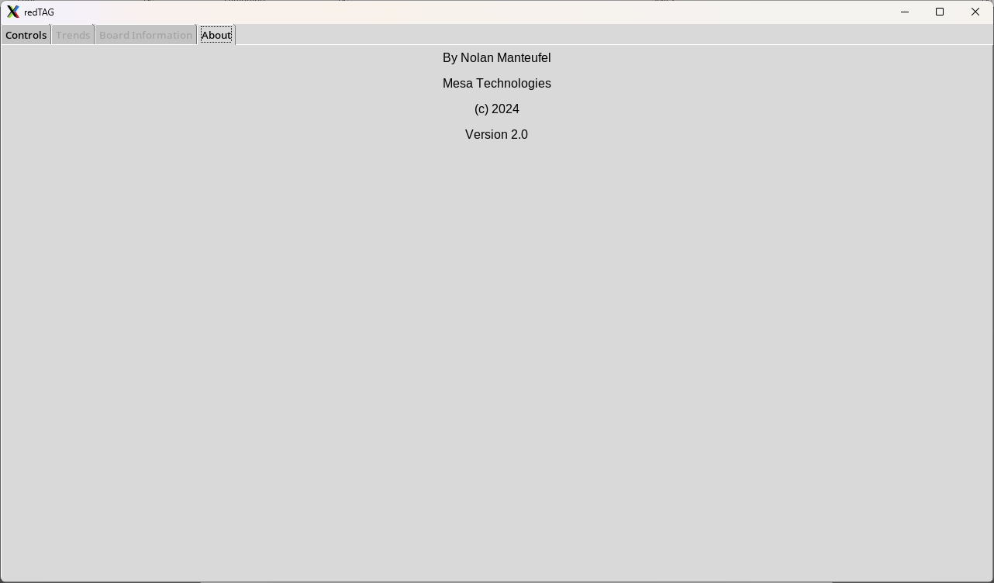

# End of Appendix

# Revision History

|  |  |  |  |
| --- | --- | --- | --- |
| REV | DESCRIPTION | ECO | DATE |
| A | Initial Release, v2.0 | N/A | 09SEP2024 |
|  |  |  |  |